|  |  |
| --- | --- |
| DEPARTMENT OF INFORMATION TECHNOLOGY  A.P.SHAH INSTITUTE OF TECHNOLOGY  G.B. Road, Kasarvadavali, Thane (W), Mumbai-400615  UNIVERSITY OF MUMBAI  Academic year: 2022-23  **HAPPY HOME**  S.E. - I.T Engineering  Submitted By  **Abhiti Rachel 21104093**  **Sakshi Jagtap 21104082**  **Urvi Joshi 21104100**  Under The Guidance Of  **Prof. Shital Agrawal** | |
| **CERTIFICATE**        This to certify that the Mini Project report on **HAPPY HOME** has been submitted by **Abhiti Rachel**,  **Sakshi Jagtap** and **Urvi Joshi** who are a Bonafede students of A.P Shah Institute of Technology,  Thane, Mumbai, as a partial fulfilment of requirement for the degree in **Information Technology**,  during the academic year **2022-2023** in the satisfactory manner as per the curriculum laid down by  University of Mumbai.      Prof.Shital Agarwal  Guide      Dr. Kiran Deshpande Dr. Uttam D.Kolekar  Head Department of Information Technology Principal      External Examiner(s)  1.  2.    Place: A.P. Shah Institute of Technology, Thane Date: |

|  |
| --- |
| **TABLE OF CONTENTS**     1. Introduction.......................................................................................................... 1   1.1. Purpose..................................................................................................... 1  1.2. Objectives................................................................................................. 1  1.3. Scope........................................................................................................ 2   1. Problem Definition………………….................................................................... 3 2. Proposed System………....................................................................................... 4   3.1. Features and Functionality…………………………………………………...4   1. Project Outcomes.................................................................................................. 7 2. Software Requirements ........................................................................................ 8 3. Project Design........................................................................................................9 4. Project Scheduling...............................................................................................15   8.Conclusion………..................................................................................................16  References |

**CHAPTER 1**

1. **INTRODUCTION:**

The more we give, the more we get. This quote absolutely true because people nowadays had just realized the good of donation for themselves. When donating something to needy, it just not the donors' satisfaction but also can tighten-the-bond between donor and recipient. But, hapless there is still a small group of non-integrity people who like to cheat on others. For this urbanization era, all matters are promoted on media social nor an advertisement. Unfortunately, not all of them are true. Some of the guiltless donors might be received from the scammer. The donation will go for their owns good instead of giving to the needy.

**1.1PURPOSE:**

This application is developed completely for the donors to donate anything to the welfare home. This platform is totally avoiding from any scammers who intended to take the donation's item for their own sake. The system will record all the donor's info. Date and time delivering and received the item also will be recorded in the database. The user can choose which category of their donation

* 1. **OBJECTIVE:**

* To ease the donors who wish to make a donation but do not know where to donate it.
* To avoid fraud issues regarding stolen money or any donation item or their satisfactory
* To raise donations for abandoned and lonely senior citizens
* To make user friendly system for volunteers
* To provide emotional support to overcome social isolation.
  1. **SCOPE:**

The scope of this project are mainly focuses on the development of application for donors out there who are intended to donate things but do not have any idea where to donate it.

The donor can donate the item by clicking based on the category and search any listed welfare home. All the welfare home involved are registered in the system.

It will allow donors to easily access the platform and make donations from anywhere and at any time.

This application will include features such as secure payment processing, and feedback and rating system. These features will ensure that the donations are secure.

**CHAPTER 2**

1. PROBLEM STATEMENT:

Charity fraud schemes seek donations for organizations that do little or no work instead, the money goes to the fake charity's creator. These kind of frauds will make people suspicious to donate their money to the welfare homes. This application will help a lot to prevent those negative issues. Cheating issues by non-integrity people rising illegally these days, this application is a platform for people who have no idea where to donate and some might have no time to go to the place to give their donation's item. The main problems can be highlighted for this

**CHAPTER 3**

**3.PROPOSED SYSTEM:**

This application is developed completely for the donors to donate anything to the welfare home. This platform is totally avoiding from any scammers who intended to take the donation's item for their own sake. The system will record all the donor's info. Date and time delivering and received the item also will be recorded in the database. The user can choose which category of their donation. Lists of welfare home also provided

**3.1 FEATURES AND FUCTIONALITY:**

1.Payment Portal :

* Followed by payment gateway
* Receipts
* Thank you message

2.Location:

* Provision of contact numbers
* Location of old age homes for visitors.

3.Welfare Donations:

* Food
* Clothes

4.User Dashboard:

* User information
* Payment Receipts
* Feedback form

**CHAPTER 4**

**4.PROJECT OUTCOME:**

The donation platform will have a user-friendly interface that allows donors to sign up and log in securely. Once logged in, they will be able to select the category of donation and choose from a list of verified welfare homes.

Donors can then add the details of their donation, including the type of item, quantity, and delivery date. The system will record all the information, including the donor's name, address, and contact details, as well as the date and time.

Welfare homes will be able to view and manage the donations they have received through the platform, and can also update their details and donation requirements as needed.

The platform will also include a payment processing system for monetary donations. Donors will be able to make a secure donation using a secure payment gateway.

Finally, the platform will include a feedback and rating system, allowing donors to rate the welfare homes and leave comments on their experience. This will help maintain accountability and transparency and allow the welfare homes to improve their services.

Overall, the donation platform will provide a convenient and secure way for donors to contribute to welfare homes and help those in need.

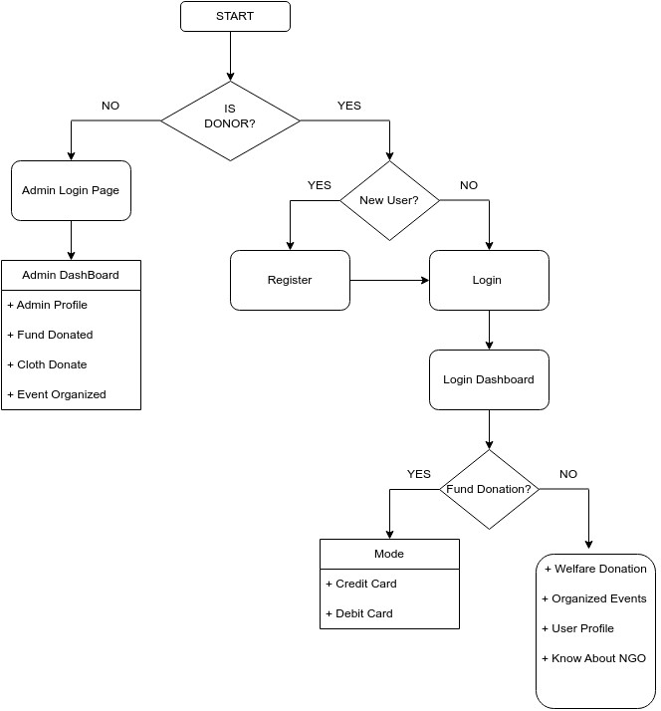

Fig3.1: Flowchart

**CHAPTER 5**

**5.SOFTWARE REQUIREMENTS:**

1.Tkinter:

Tkinter is one of the Python libraries which contains many functions for the development of GUI graphical user interface) pages and windows.

2.MySql:

MySQL is an open-source relational database management system

3.Pycharm IDE:

It is a dedicated Python Integrated Development Environment. IDE provides a wide range of essential tools for python developers.

**CHAPTER 6**

**6.PROJECT DESIGN**:

1. Index Page:

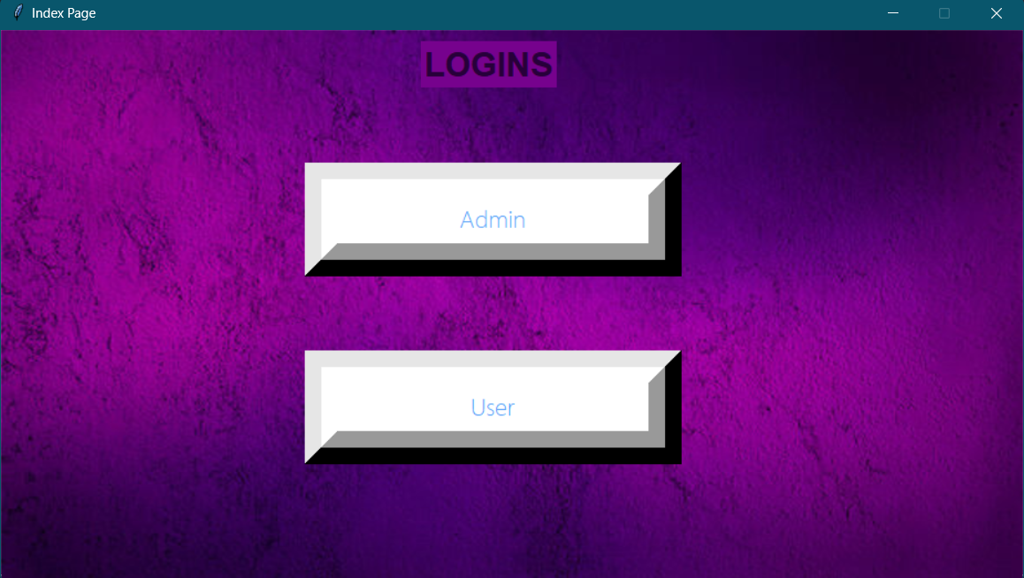

1. If you choose USER on the index page then you will be directed to User Login Page

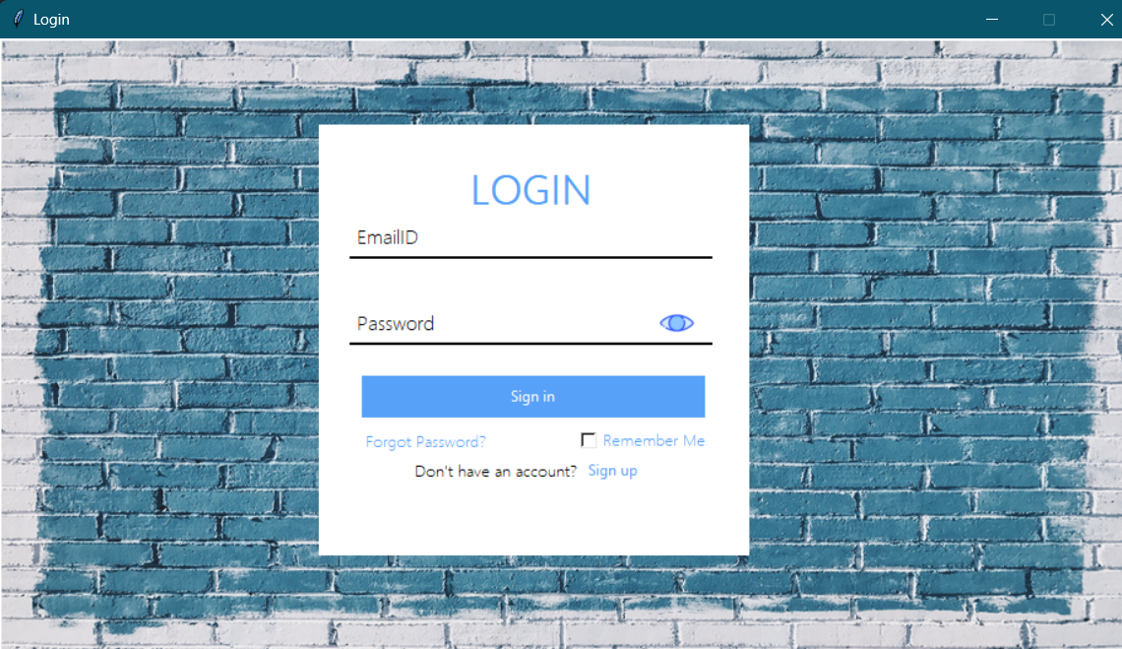

1. If the User wants to register redirect to the Registration Page.

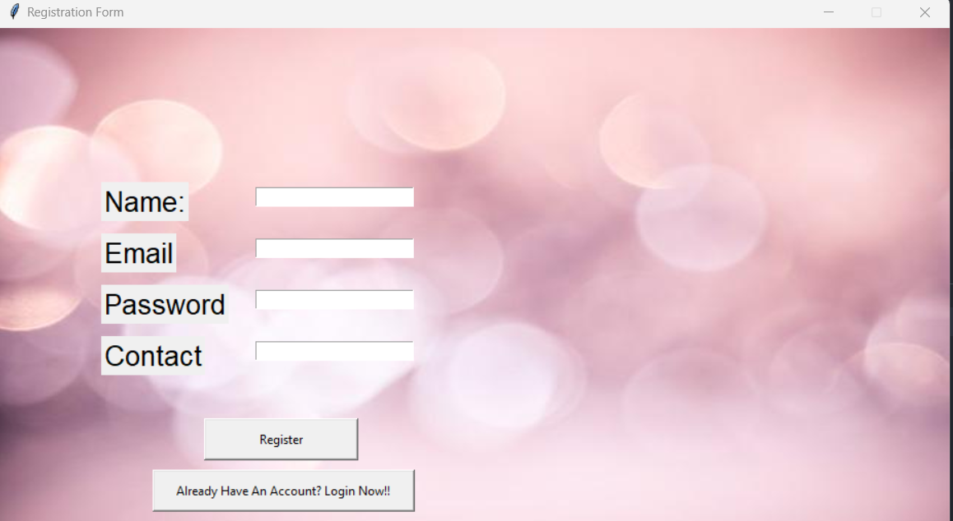

1. If the User has forgotten the Password, redirect to the Reset Password Page.

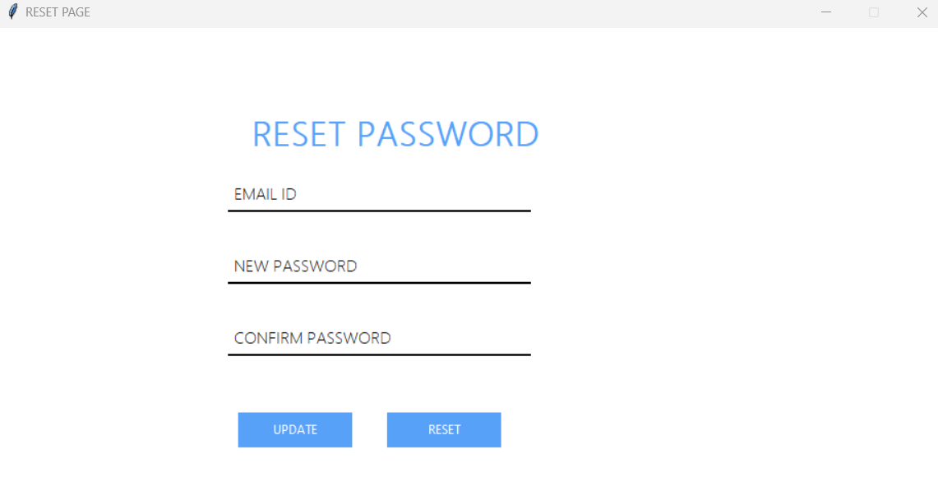

1. After the User Has Successfully Login, Redirect to User Dashboard.

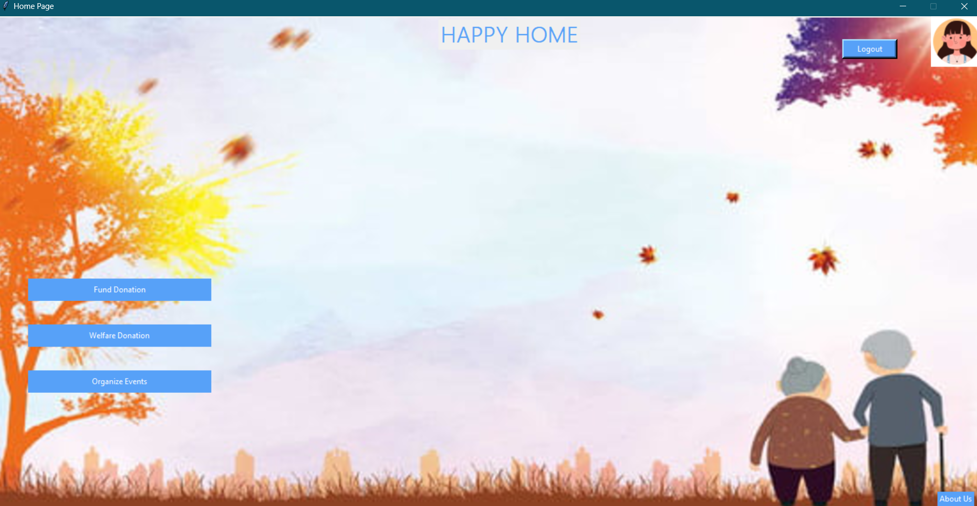

6. If the User wants to Donate Funds then choose the mode and redirect to the respective pages

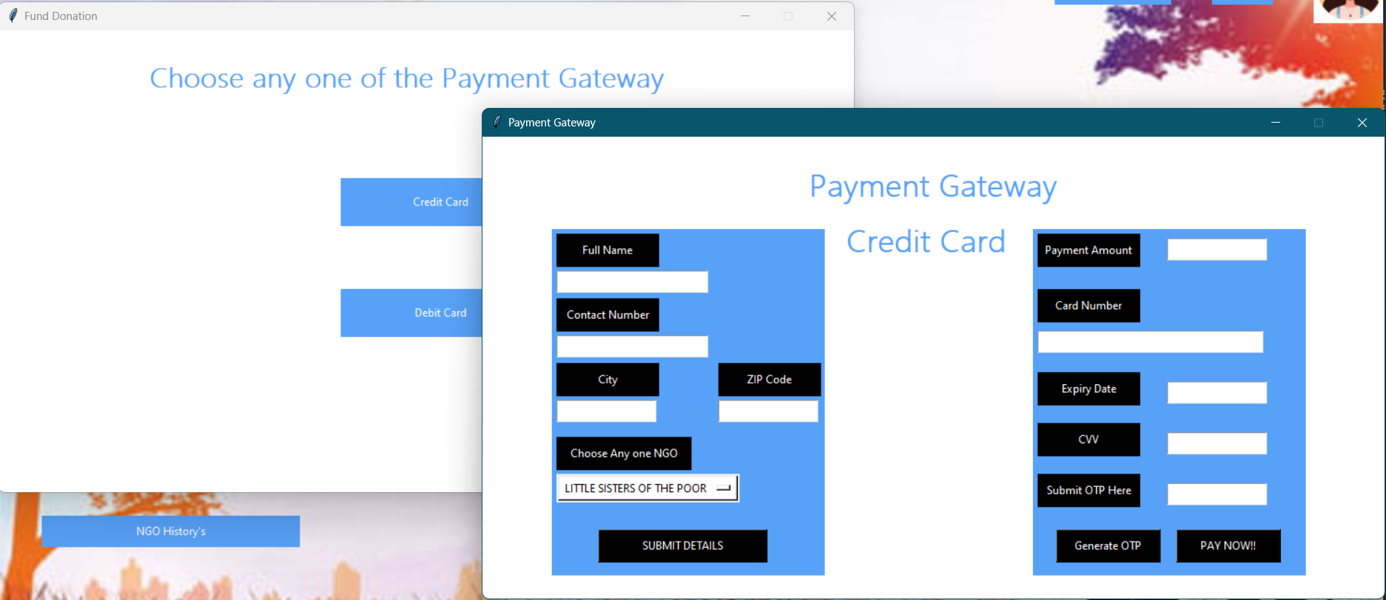

7. If the User wants to make a Welfare Donation then choose the donations options and redirect to the respective pages.

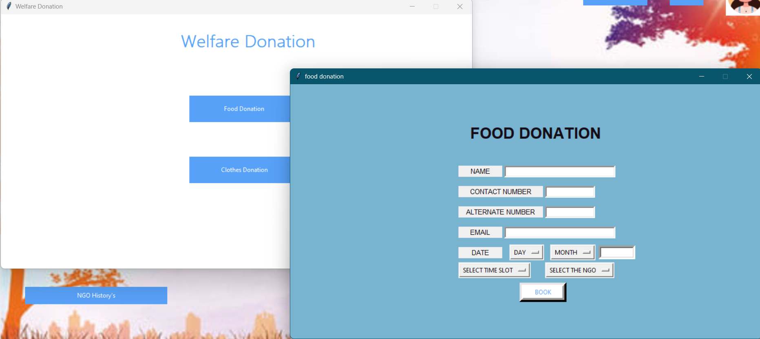

8. Users can also see their Profile details in the profile icon button.

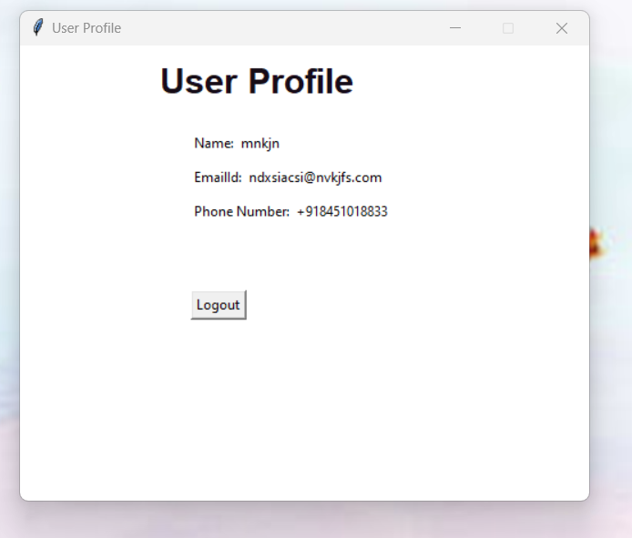

9. If you choose ADMIN on the index page then Admin Login Page will Appear.

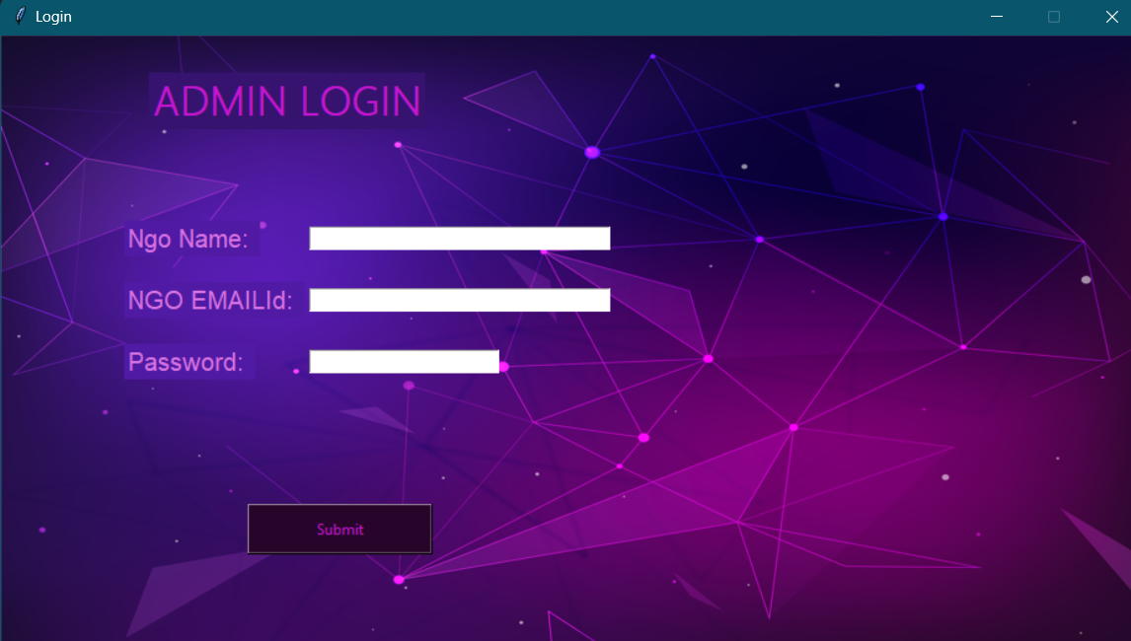

10. After the Admin is Successfully logged in, they will be redirected to Admin Dashboard.

Admin will also be able see their profile details in the profile icon button.

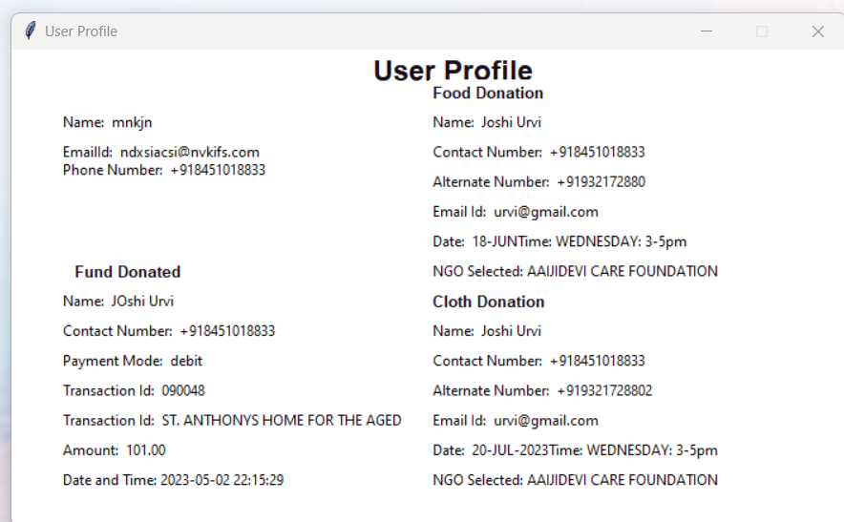

DATABASE:

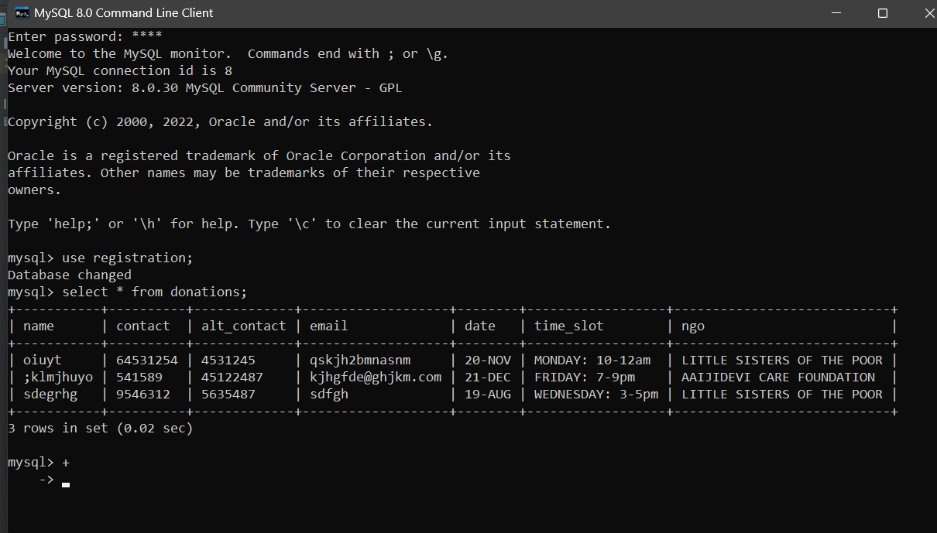

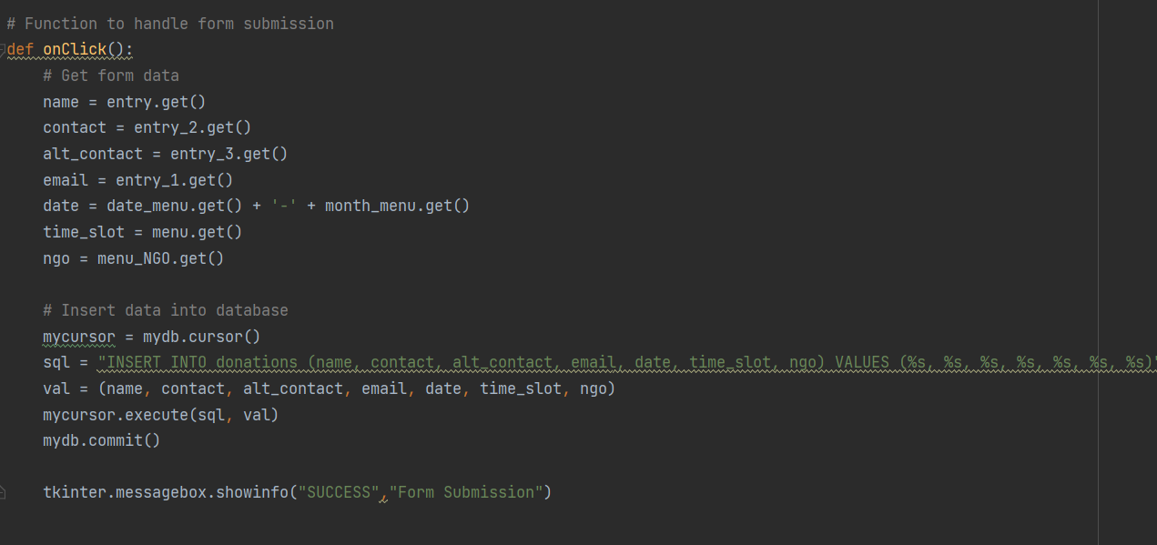

**Chapter 7**

**Project Scheduling:**

|  |  |  |  |
| --- | --- | --- | --- |
| **Sr.**  **No** | **Group Member** | **Time duration** | **Work to be done** |
| **1.** | SAKSHI JAGTAP  ABHITI RACHEL.K  URVI JOSHI | In the month of January. | Creating GUI using Tkinter |
| **2.** | In the month of February. | Creating Database connectivity. |
| **3.** | In the month of  March and April. | API and Connectivity between all the pages |

**CHAPTER 8**

**CONCLUSION:**

Creating a donation platform for welfare homes can be a great initiative to facilitate donations and ensure they reach the intended recipients. By providing a user-friendly interface, donor authentication, a list of verified welfare homes, donation categories, payment processing system, and feedback and rating system, the platform can provide a secure and transparent way for donors to make donations.

The donation platform can record all the necessary information, including the donor's name, address, and contact details, as well as the date and time of delivery and receipt of the donation.

Overall, this application can be a great platform to connect donors with welfare homes and provide much-needed support to those in need.

# REFERENCES :

* Effective Computation in Physics: Field Guide to Research with Python
* Fluent Python: Clear, Concise, and Effective Programming
* Python Crash Course – 2nd Edition
* Python Cookbook: Recipes for Mastering Python 3